In writer’s workshop, students will plan, draft, & organize. We will continue to focus on the Informational genre & writing to inform.

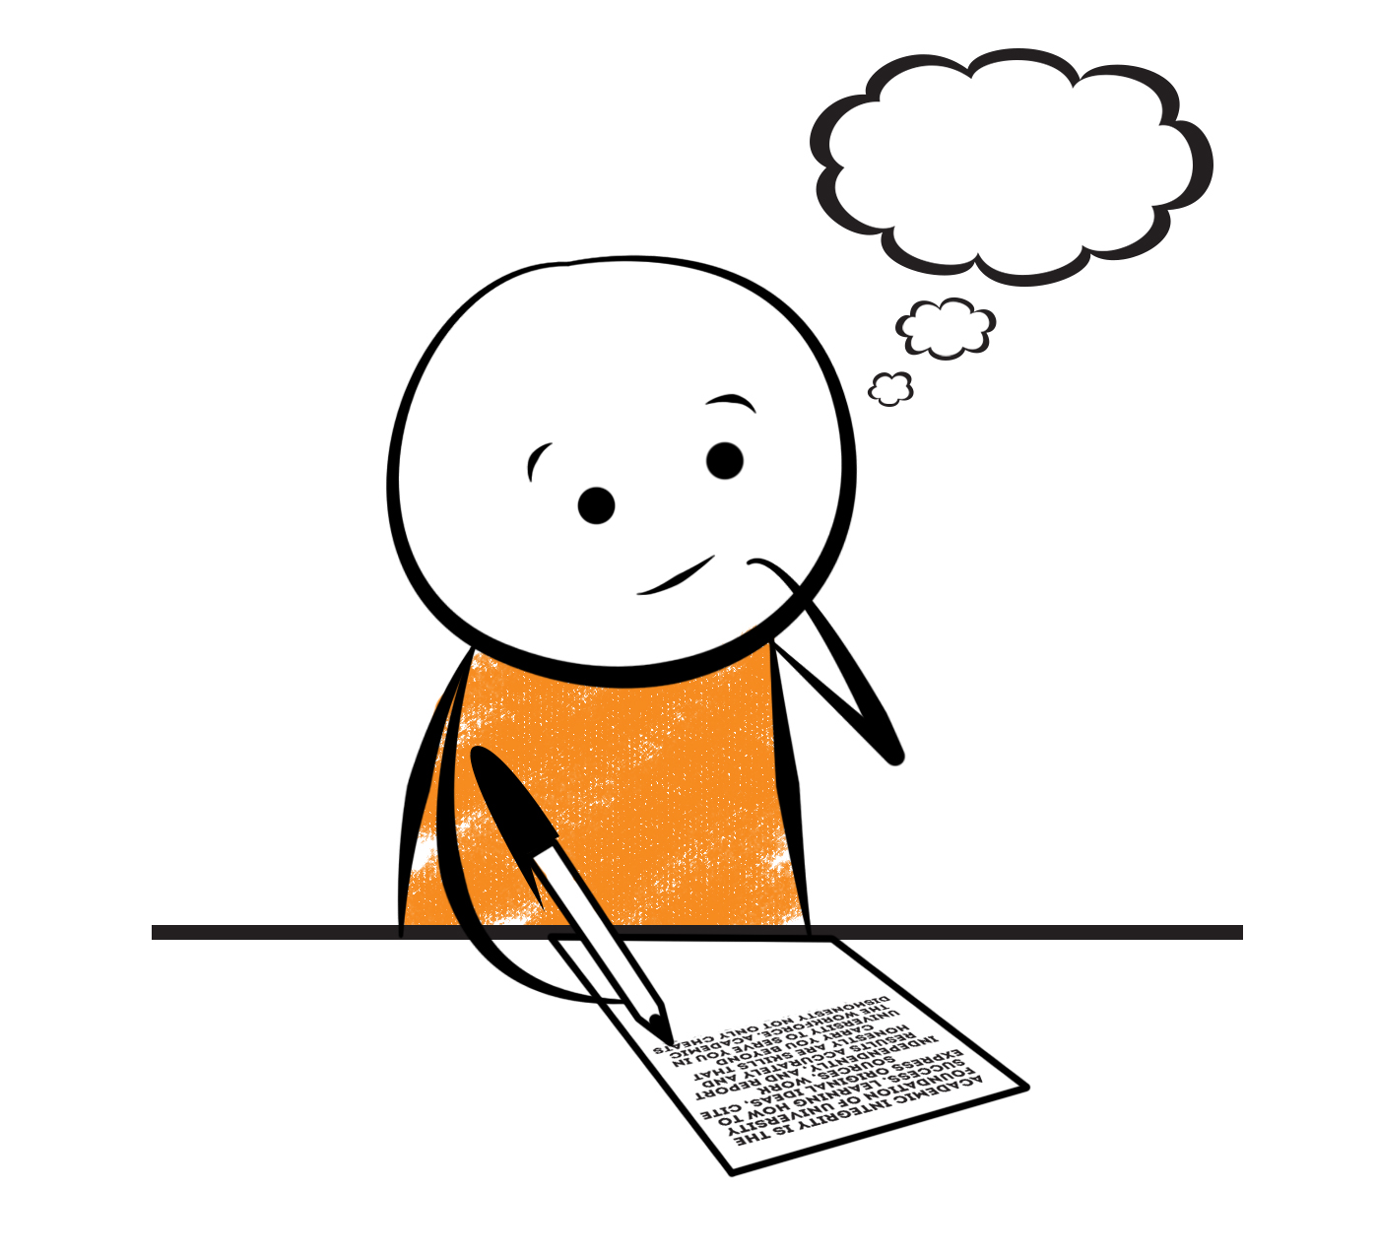

**2nd Grade Fridge Facts**

**Apr. 16th – Apr. 20th**

[](http://www.google.com/imgres?imgurl=http://pad2.whstatic.com/images/thumb/4/4b/MNKY07.JPG/300px-MNKY07.JPG&imgrefurl=http://www.wikihow.com/Draw-a-Cartoon-Monkey-Face&usg=__R59DajZ-oRuc0Bs2tqwaCqkeyrc=&h=215&w=300&sz=13&hl=en&start=47&zoom=1&tbnid=lFt_dXax-slmVM:&tbnh=121&tbnw=160&ei=ULAwTcbrL8H78AbdsYTQCA&prev=/images?q=cute+cartoon+monkey&um=1&hl=en&rlz=1T4GGHP_enUS412US412&biw=1259&bih=564&tbs=isch:1&um=1&itbs=1&iact=hc&vpx=260&vpy=172&dur=765&hovh=172&hovw=240&tx=97&ty=88&oei=RbAwTZWMM8WxtAar4aiHCg&esq=3&page=3&ndsp=22&ved=1t:429,r:16,s:47)

Science

Animal & Plant Life Cycles

Social Studies

Economics

**.**

[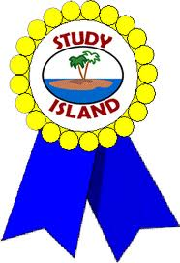](http://www.google.com/imgres?imgurl=http://see.edmonson.k12.ky.us/index_files/StudyislandRibbon.gif&imgrefurl=http://www.millstone.k12.nj.us/teachers/millerj/index.htm&usg=__kVi5j8TDMQias-or_zRD46GlXUQ=&h=366&w=251&sz=11&hl=en&start=7&zoom=1&tbnid=CdoraXaINdFg6M:&tbnh=122&tbnw=84&ei=FamGTdn6B-ay0QHJkfzjCA&prev=/images?q=study+island&um=1&hl=en&rlz=1T4GGHP_enUS412US412&biw=1259&bih=564&tbs=isch:1&um=1&itbs=1)9th

**Important Reminders**

* School starts promptly at 7:45. Please make sure your

child is on time. Drop off begins at 7:10 am.

* If your child has a change in transportation, please

send his/her teacher a note.

*Our school will begin collecting jars of peanut butter and jelly to “Spread the Love” from April 16 – May 18. All donations will benefit the CARES Food Pantry!

* Yearbooks are on sale for $30.00. They can also be purchased on-line at [www.balfour.com](http://www.balfour.com) for $27.00 (last day to order on-line is May 1st).

* April 20 – Field Trip to Funk Heritage Center; Progress Reports

* May 5 – Math Bowl @ Hill City Elementary School

* May 22 – Field Day 8:30 – 10:45 am; End of the Year Awards Assembly at 11:45 am

* May 25 – Last Day of School

|  |  |
| --- | --- |
|  |  |
|  | |

**Reading**

On Tuesday, we will begin reading “Day of the Dragon King” **(L.20)** by Mary Pope Osborne. We will concentrate on comprehension, fluency, vocabulary, text structure, making predictions, and writing a summary.

**To Be Announced….**

Comprehension Test on “Day of the Dragon King” **(L.20)**

**(This is a 2 week novel study.)**

**\*\*Monday, April 16 – “Jackie Robinson” Test\*\***

Our lunchtime is at 11:57. You are welcome to

matter.

M

**Group 2 Spelling Words (L.20) “Day of the Dragon King”**

***No Spelling Words this week!***

***No Spelling Tic-Tac-Toe!***

**Math**

We will continue to focus our attention on three-digit addition and subtraction. The main focus in this unit is on regrouping or borrowing with three-digit numbers. In this unit, students will explore adding and subtracting three-digit numbers, use mental math to add and subtract and find missing parts of a number sentence, and use logical reasoning to solve word problems. Please continue to practice those basic addition and subtraction facts at home as well as adding and subtracting with regrouping.



**2nd Grade Teacher’s**

**Contact Information**

E-mail:

[kellybryson@.pickenscounty](mailto:kellybryson@.pickenscounty) schools.org

[matthewgibson@.pickenscountyschools.org](mailto:matthewgibson@.pickenscountyschools.org)

[lizpatrick@.pickenscounty schools.org](mailto:lizpatrick@.pickenscounty%20schools.org)

[agaylayoung@.pickenscounty schools.org](mailto:agaylayoung@.pickenscounty%20%20schools.org)

**Phone**:

706-253-1730

School Webpage:

<http://jasperele.pickens.k12.ga.us/>

(You will find links on the school’s webpage to all of the second grade teachers’ webpages.)

**Vocabulary Words (L.20) “Day of the Dragon King”**

**We will read and discuss many vocabulary words. However, students will not have a vocabulary test. Students will do different activities focusing on the vocabulary words as we read “Day of the Dragon King.”**

 ou

**Group 1 Spelling Words (L.20)**

**“Day of the Dragon King”**

***No Spelling Words this week!***

***No Spelling Tic-Tac-Toe!***