In writer’s workshop, students will plan, draft, & organize. We will continue to focus on the Narrative genre & writing & elaborating with detail.

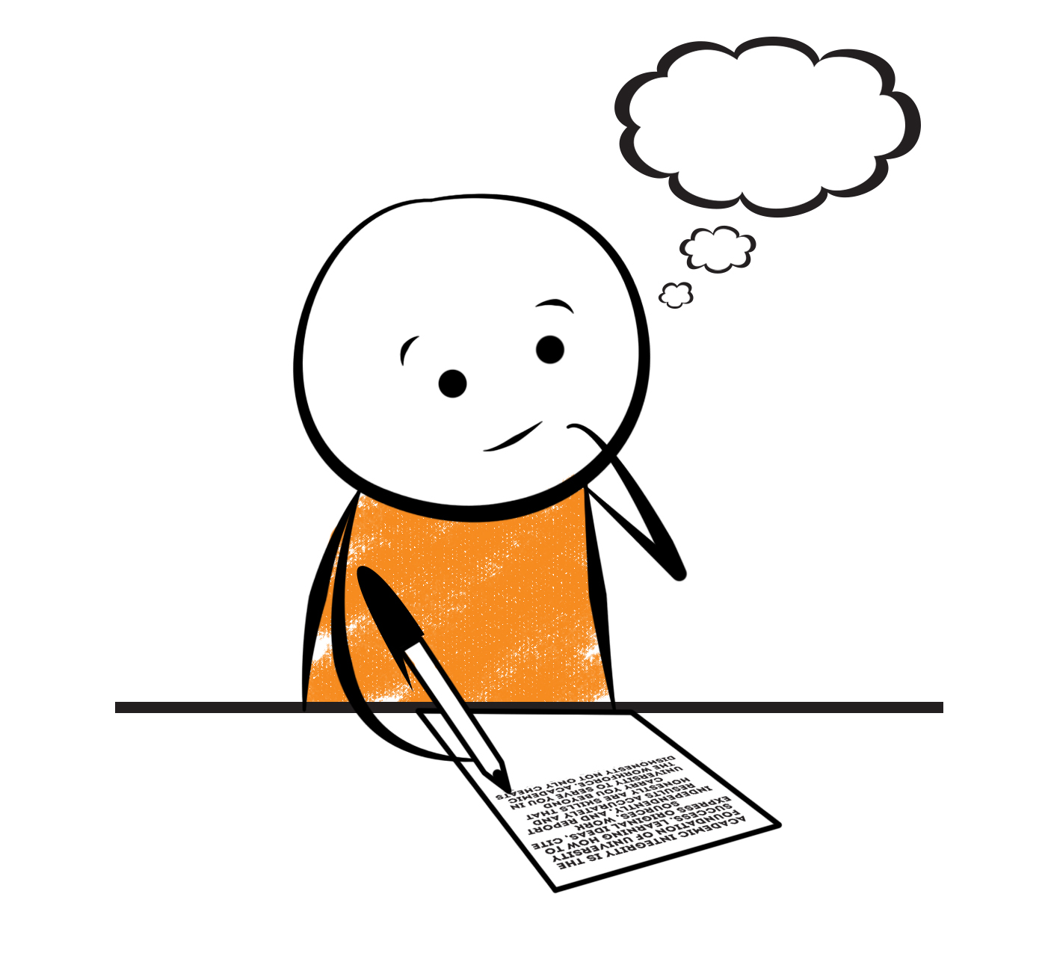

**2nd Grade Fridge Facts**

**Dec. 18th – Dec. 21st**

[](http://www.google.com/imgres?imgurl=http://pad2.whstatic.com/images/thumb/4/4b/MNKY07.JPG/300px-MNKY07.JPG&imgrefurl=http://www.wikihow.com/Draw-a-Cartoon-Monkey-Face&usg=__R59DajZ-oRuc0Bs2tqwaCqkeyrc=&h=215&w=300&sz=13&hl=en&start=47&zoom=1&tbnid=lFt_dXax-slmVM:&tbnh=121&tbnw=160&ei=ULAwTcbrL8H78AbdsYTQCA&prev=/images?q=cute+cartoon+monkey&um=1&hl=en&rlz=1T4GGHP_enUS412US412&biw=1259&bih=564&tbs=isch:1&um=1&itbs=1&iact=hc&vpx=260&vpy=172&dur=765&hovh=172&hovw=240&tx=97&ty=88&oei=RbAwTZWMM8WxtAar4aiHCg&esq=3&page=3&ndsp=22&ved=1t:429,r:16,s:47)

Science

**Forms of Energy**

Social Studies

Creek and Cherokee Indians

**.**

[](http://www.google.com/imgres?imgurl=http://see.edmonson.k12.ky.us/index_files/StudyislandRibbon.gif&imgrefurl=http://www.millstone.k12.nj.us/teachers/millerj/index.htm&usg=__kVi5j8TDMQias-or_zRD46GlXUQ=&h=366&w=251&sz=11&hl=en&start=7&zoom=1&tbnid=CdoraXaINdFg6M:&tbnh=122&tbnw=84&ei=FamGTdn6B-ay0QHJkfzjCA&prev=/images?q=study+island&um=1&hl=en&rlz=1T4GGHP_enUS412US412&biw=1259&bih=564&tbs=isch:1&um=1&itbs=1)9th

**Important Reminders**

* School starts promptly at 7:45. Please make sure your

child is on time. Drop off begins at 7:10 am.

* If your child has a change in transportation, please

send his/her teacher a note.

*This year, our school is collecting Pop Tarts for the “Paw Packs” Weekend Snack Program. All donations are greatly appreciated!

* December 18 – 21 – Christmas Book Character Dress-Up (Please see the dress-up schedule on the back.)

* December 21 – Classroom Christmas Parties @1:00 pm

* December 22 – January 5 – Christmas Holidays

* January 12 – Report Cards

* January 15 – Martin Luther King Holiday (No School)

|  |  |
| --- | --- |
|  |  |
|  | |

**Reading**

This is a test free week! We will enjoy reading and doing a Novel Study on “December Secrets” together in class.

**\*Please continue to practice reading Fry Words.\***

Our lunchtime is at 11:57. You are welcome to

matter.

M

***No Spelling words this week!***

**Math**

We will continue to focus our attention on adding two-digit numbers. Our main focus in this unit will be on regrouping. Students will regroup 10 ones for 1 ten and practice adding two- and one-digit numbers as well as adding 2 two-digit numbers. Students will use number lines to model two-digit addition. We will also work on adding 3 and 4 two-digit numbers using strategies such as double, counting on, and making 10. Please continue to practice those basic addition and subtraction facts at home as well as subtracting with regrouping (borrowing).



**2nd Grade Teacher’s**

**Contact Information**

E-mail:

[kellybryson@.pickenscounty](mailto:kellybryson@.pickenscounty) schools.org

[matthewgibson@.pickenscountyschools.org](mailto:matthewgibson@.pickenscountyschools.org)

[lizpatrick@.pickenscounty schools.org](mailto:lizpatrick@.pickenscounty%20schools.org)

[agaylayoung@.pickenscounty schools.org](mailto:agaylayoung@.pickenscounty%20%20schools.org)

**Phone**:

706-253-1730

School Webpage:

<http://jasperele.pickens.k12.ga.us/>

(You will find links on the school’s webpage to all of the second grade teachers’ webpages.)

***We will increase our vocabulary through our Novel Study in class. No Vocabulary Test this week!***

 ou

***No Spelling words this week!***