In writer’s workshop, students will plan, draft, & organize. We will continue to focus on the Narrative genre & writing & elaborating with detail.

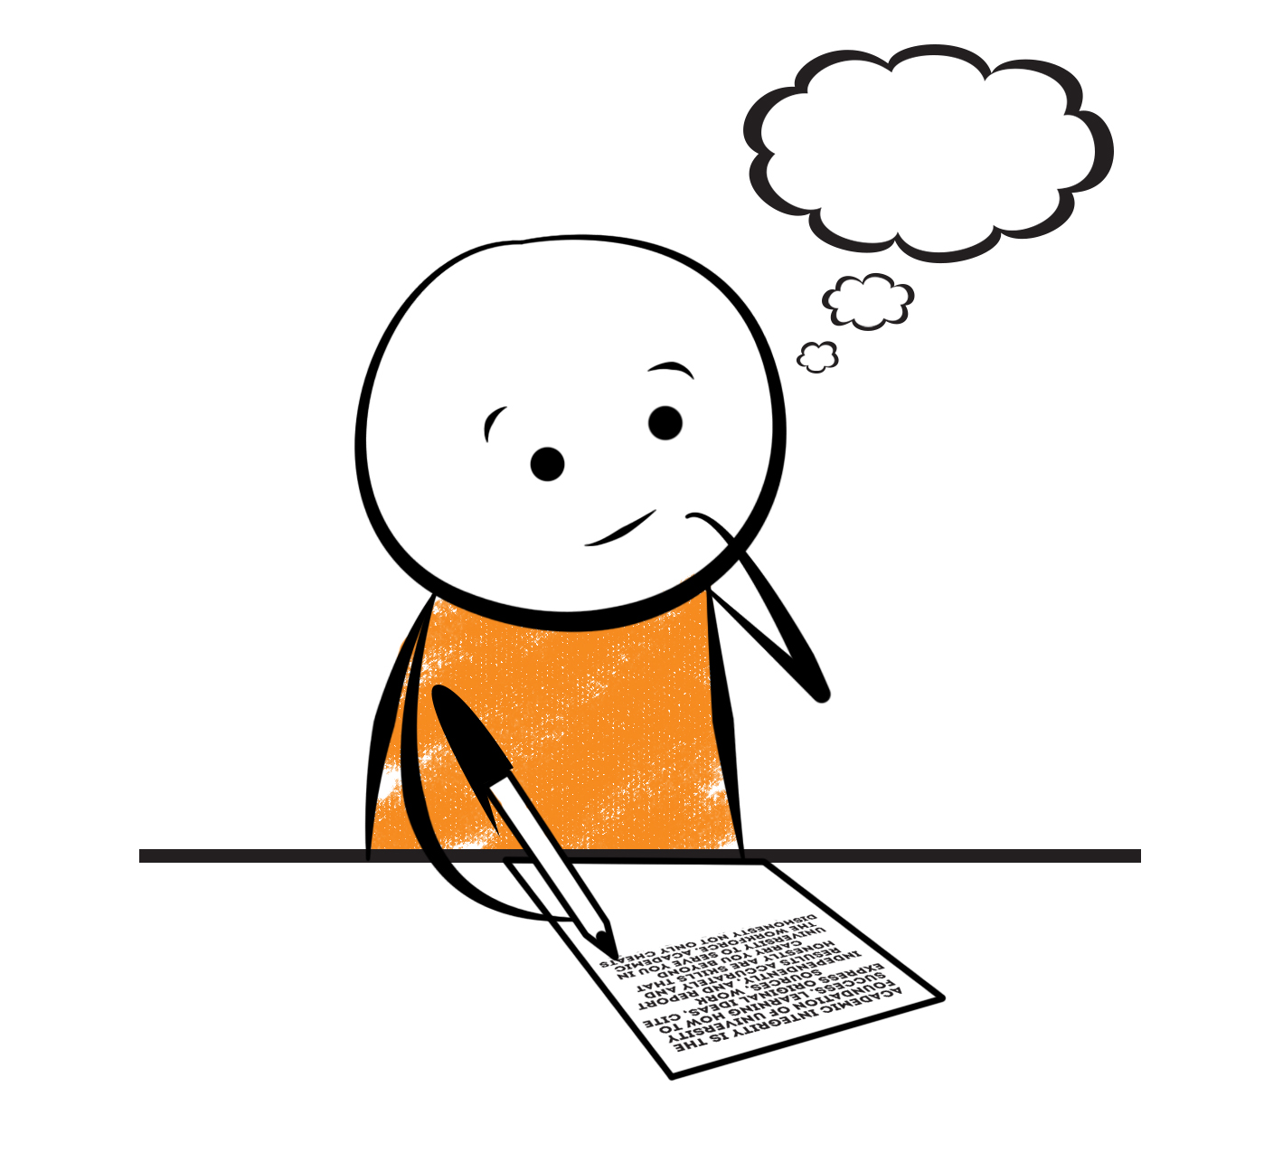

**2nd Grade Fridge Facts**

**Dec. 4th – Dec. 8th**

[](http://www.google.com/imgres?imgurl=http://pad2.whstatic.com/images/thumb/4/4b/MNKY07.JPG/300px-MNKY07.JPG&imgrefurl=http://www.wikihow.com/Draw-a-Cartoon-Monkey-Face&usg=__R59DajZ-oRuc0Bs2tqwaCqkeyrc=&h=215&w=300&sz=13&hl=en&start=47&zoom=1&tbnid=lFt_dXax-slmVM:&tbnh=121&tbnw=160&ei=ULAwTcbrL8H78AbdsYTQCA&prev=/images?q=cute+cartoon+monkey&um=1&hl=en&rlz=1T4GGHP_enUS412US412&biw=1259&bih=564&tbs=isch:1&um=1&itbs=1&iact=hc&vpx=260&vpy=172&dur=765&hovh=172&hovw=240&tx=97&ty=88&oei=RbAwTZWMM8WxtAar4aiHCg&esq=3&page=3&ndsp=22&ved=1t:429,r:16,s:47)

Science

**Forms of Energy**

Social Studies

Creek and Cherokee Indians

**.**

[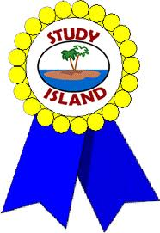](http://www.google.com/imgres?imgurl=http://see.edmonson.k12.ky.us/index_files/StudyislandRibbon.gif&imgrefurl=http://www.millstone.k12.nj.us/teachers/millerj/index.htm&usg=__kVi5j8TDMQias-or_zRD46GlXUQ=&h=366&w=251&sz=11&hl=en&start=7&zoom=1&tbnid=CdoraXaINdFg6M:&tbnh=122&tbnw=84&ei=FamGTdn6B-ay0QHJkfzjCA&prev=/images?q=study+island&um=1&hl=en&rlz=1T4GGHP_enUS412US412&biw=1259&bih=564&tbs=isch:1&um=1&itbs=1)9th

**Important Reminders**

* School starts promptly at 7:45. Please make sure your

child is on time. Drop off begins at 7:10 am.

* If your child has a change in transportation, please

send his/her teacher a note.

*This year, our school is collecting Pop Tarts for the “Paw Packs” Weekend Snack Program. All donations are greatly appreciated!

* December 4 – 8 – Santa Shop

* December 5 & 7 – Christmas Caroling in the Lobby

* December 7 – Camp Christmas Program 6 – 8 pm

* December 12 – Parent’s Night Out through 7 pm

* December 18 – 21 – Christmas Book Character Dress-Up

* December 21 – Classroom Christmas Parties @1:30 pm

* December 22 – January 5 – Christmas Holidays

* January 12 – Report Cards

|  |  |
| --- | --- |
|  |  |
|  | |

**Reading**

We will continue reading “The Kidnapped King” **(L.9-L.10)** by Ron Roy. We will concentrate on comprehension, fluency, vocabulary, and increasing our knowledge of conflict and resolution within the plot of a story.

**Tuesday, December 12**

Comprehension Test on “The Kidnapped King” **(L.9)**

**Monday, December 11**

Spelling/Vocabulary Test with **Lesson 10** words

**\*Please continue to practice reading Fry Words.\***

Our lunchtime is at 11:57. You are welcome to

matter.

M

**Group 2 Spelling Words (L.10) “The Kidnapped King”**

blink cry flight

crisp fly fight

slice try rely

pride high delight

glide height widen

**Math**

We will begin focusing our attention on adding two-digit numbers. Our main focus in this unit will be on regrouping. Students will regroup 10 ones for 1 ten and practice adding two- and one-digit numbers as well as adding 2 two-digit numbers. Students will use number lines to model two-digit addition. We will also work on adding 3 and 4 two-digit numbers using strategies such as double, counting on, and making 10. Please continue to practice those basic addition and subtraction facts at home as well as subtracting with regrouping (borrowing).



**2nd Grade Teacher’s**

**Contact Information**

E-mail:

[kellybryson@.pickenscounty](mailto:kellybryson@.pickenscounty) schools.org

[matthewgibson@.pickenscountyschools.org](mailto:matthewgibson@.pickenscountyschools.org)

[lizpatrick@.pickenscounty schools.org](mailto:lizpatrick@.pickenscounty%20schools.org)

[agaylayoung@.pickenscounty schools.org](mailto:agaylayoung@.pickenscounty%20%20schools.org)

**Phone**:

706-253-1730

School Webpage:

<http://jasperele.pickens.k12.ga.us/>

(You will find links on the school’s webpage to all of the second grade teachers’ webpages.)

**Vocabulary Words (L.10) “The Kidnapped King”**

**kidnapping** – is a noun that means a crime where someone takes another person and hides him or her.

**investigate** – is a verb that means to do work to understand something. When there is a crime or a mystery, we try to solve or investigate it. The work is called an investigation.

**resolution** – in a story, a resolution is the events that solve the character’s problem.

**twist** – Sometimes a mystery has a twist. It is a surprise, something that we don’t expect.

**persistent** – is an adjective that means continuing no matter what and not giving up.

 ou

**Group 1 Spelling Words (L.10)**

**“The Kidnapped King”**

blink cry flight

crisp fly fight

slice try

pride high

glide height