In writer’s workshop, students will plan, draft, & organize. We will continue to focus on the Narrative genre & writing & elaborating with detail.

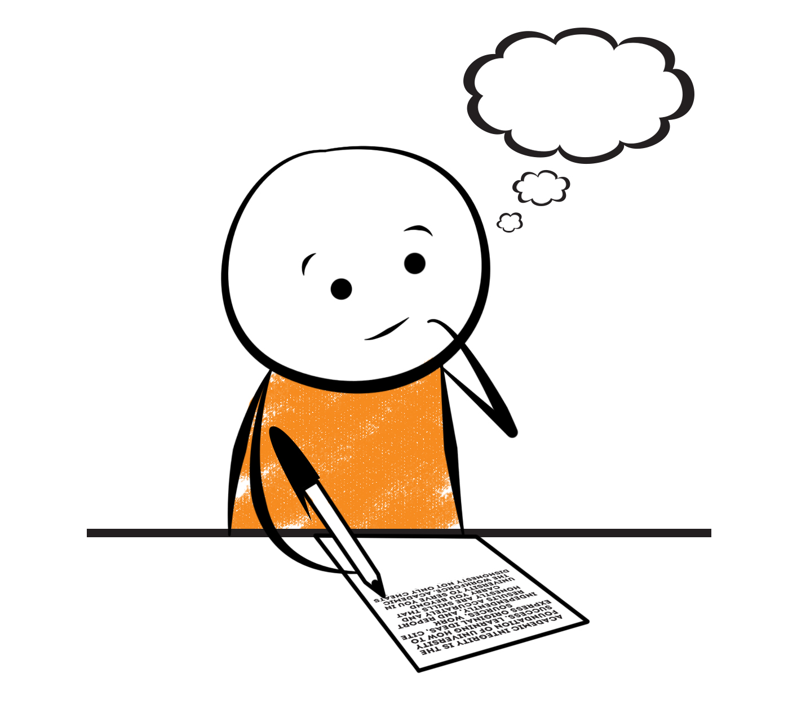

**2nd Grade Fridge Facts**

**Jan. 8th – 12th**

[](http://www.google.com/imgres?imgurl=http://pad2.whstatic.com/images/thumb/4/4b/MNKY07.JPG/300px-MNKY07.JPG&imgrefurl=http://www.wikihow.com/Draw-a-Cartoon-Monkey-Face&usg=__R59DajZ-oRuc0Bs2tqwaCqkeyrc=&h=215&w=300&sz=13&hl=en&start=47&zoom=1&tbnid=lFt_dXax-slmVM:&tbnh=121&tbnw=160&ei=ULAwTcbrL8H78AbdsYTQCA&prev=/images?q=cute+cartoon+monkey&um=1&hl=en&rlz=1T4GGHP_enUS412US412&biw=1259&bih=564&tbs=isch:1&um=1&itbs=1&iact=hc&vpx=260&vpy=172&dur=765&hovh=172&hovw=240&tx=97&ty=88&oei=RbAwTZWMM8WxtAar4aiHCg&esq=3&page=3&ndsp=22&ved=1t:429,r:16,s:47)

Science

**Forms of Energy**

Social Studies

Creek and Cherokee Indians

**.**

[](http://www.google.com/imgres?imgurl=http://see.edmonson.k12.ky.us/index_files/StudyislandRibbon.gif&imgrefurl=http://www.millstone.k12.nj.us/teachers/millerj/index.htm&usg=__kVi5j8TDMQias-or_zRD46GlXUQ=&h=366&w=251&sz=11&hl=en&start=7&zoom=1&tbnid=CdoraXaINdFg6M:&tbnh=122&tbnw=84&ei=FamGTdn6B-ay0QHJkfzjCA&prev=/images?q=study+island&um=1&hl=en&rlz=1T4GGHP_enUS412US412&biw=1259&bih=564&tbs=isch:1&um=1&itbs=1)9th

**Important Reminders**

* School starts promptly at 7:45. Please make sure your

child is on time. Drop off begins at 7:10 am.

* If your child has a change in transportation, please

send his/her teacher a note.

*This year, our school is collecting Pop Tarts for the “Paw Packs” Weekend Snack Program. All donations are greatly appreciated!

* January 12 – Report Cards

* January 15 – Martin Luther King Holiday (No School)

* January 18 – Writing Night 6-8 pm (Pizza will be served)

* February 9 – Progress Reports

|  |  |
| --- | --- |
|  |  |
|  | |

**Reading**

We will begin reading “Cam Jansen and The Mystery Writer Mystery” **(L.11)** by David Adler. We will concentrate on comprehension, fluency, vocabulary, and increasing our knowledge of conflict and resolution within the plot of a story.

**Friday, January 26**

Comprehension Test on “Cam Jansen and The Mystery Writer Mystery” **(L.11)**

**Thursday, January 18**

Spelling/Vocabulary Test with **Lesson 11** words

Our lunchtime is at 11:57. You are welcome to

matter.

M

**Group 2 Spelling Words (L.11) “Cam Jansen and the Mystery Writer Mystery”**

grip fright wild

bring light child

drive might polite

price night lighten

bite mild childish

**Math**

We will continue to focus our attention on adding two-digit numbers. Our main focus in this unit will be on regrouping. Students will regroup 10 ones for 1 ten and practice adding two- and one-digit numbers as well as adding 2 two-digit numbers. Students will use number lines to model two-digit addition. We will also work on adding 3 and 4 two-digit numbers using strategies such as double, counting on, and making 10. Please continue to practice those basic addition and subtraction facts at home as well as subtracting with regrouping (borrowing).



**2nd Grade Teacher’s**

**Contact Information**

E-mail:

[kellybryson@.pickenscounty](mailto:kellybryson@.pickenscounty) schools.org

[matthewgibson@.pickenscountyschools.org](mailto:matthewgibson@.pickenscountyschools.org)

[lizpatrick@.pickenscounty schools.org](mailto:lizpatrick@.pickenscounty%20schools.org)

[agaylayoung@.pickenscounty schools.org](mailto:agaylayoung@.pickenscounty%20%20schools.org)

**Phone**:

706-253-1730

School Webpage:

<http://jasperele.pickens.k12.ga.us/>

(You will find links on the school’s webpage to all of the second grade teachers’ webpages.)

**Vocabulary Words (L.11) “Cam Jansen and the Mystery Writer Mystery”**

**exchange** – is a verb that means to give one thing and get another.

**competition** – is a noun that means any situation where someone is trying to do better than someone else. A soccer game is a competition between teams. A spelling bee is a competition between students.

**persistent** – is an adjective that means to keep going no matter what and never give up. When we read “The Kidnapped King,” we learned that in order to solve mysteries, detectives have to be persistent.

 ou

**Group 1 Spelling Words (L.11)**

**“Cam Jansen and the Mystery Writer Mystery”**

grip fright wild

bring light child

drive might

price night

bite mild