In writer’s workshop, students will plan, draft, & organize. We will continue to focus on the Narrative genre & writing & elaborating with detail.

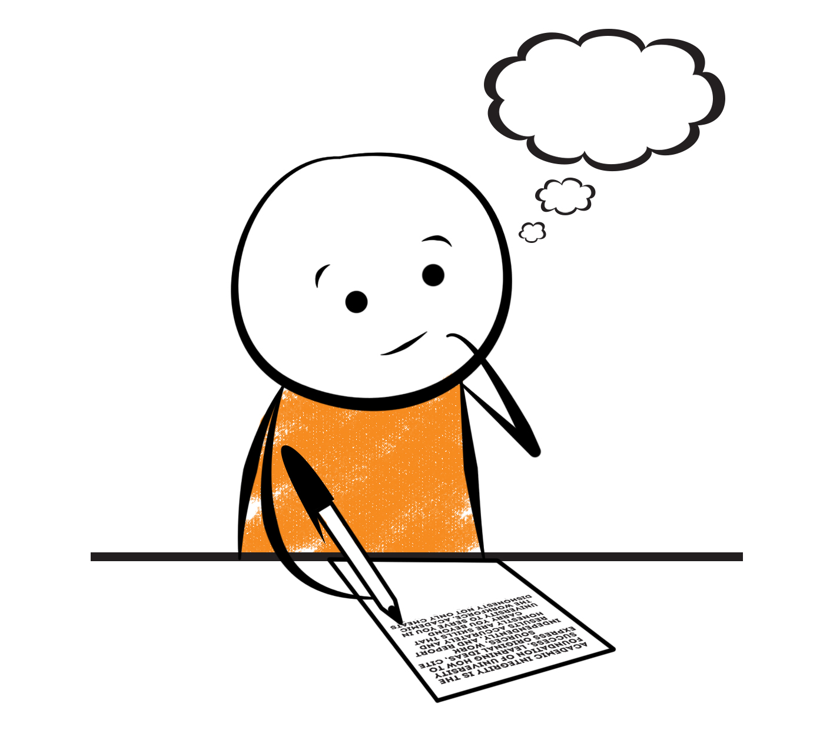

**2nd Grade Fridge Facts**

**Nov. 13th – 17th**

[](http://www.google.com/imgres?imgurl=http://pad2.whstatic.com/images/thumb/4/4b/MNKY07.JPG/300px-MNKY07.JPG&imgrefurl=http://www.wikihow.com/Draw-a-Cartoon-Monkey-Face&usg=__R59DajZ-oRuc0Bs2tqwaCqkeyrc=&h=215&w=300&sz=13&hl=en&start=47&zoom=1&tbnid=lFt_dXax-slmVM:&tbnh=121&tbnw=160&ei=ULAwTcbrL8H78AbdsYTQCA&prev=/images?q=cute+cartoon+monkey&um=1&hl=en&rlz=1T4GGHP_enUS412US412&biw=1259&bih=564&tbs=isch:1&um=1&itbs=1&iact=hc&vpx=260&vpy=172&dur=765&hovh=172&hovw=240&tx=97&ty=88&oei=RbAwTZWMM8WxtAar4aiHCg&esq=3&page=3&ndsp=22&ved=1t:429,r:16,s:47)

Science

**Changes in Matter**

Social Studies

Our Country’s Government

**.**

[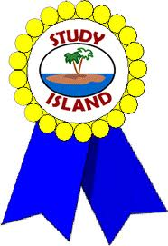](http://www.google.com/imgres?imgurl=http://see.edmonson.k12.ky.us/index_files/StudyislandRibbon.gif&imgrefurl=http://www.millstone.k12.nj.us/teachers/millerj/index.htm&usg=__kVi5j8TDMQias-or_zRD46GlXUQ=&h=366&w=251&sz=11&hl=en&start=7&zoom=1&tbnid=CdoraXaINdFg6M:&tbnh=122&tbnw=84&ei=FamGTdn6B-ay0QHJkfzjCA&prev=/images?q=study+island&um=1&hl=en&rlz=1T4GGHP_enUS412US412&biw=1259&bih=564&tbs=isch:1&um=1&itbs=1)9th

**Important Reminders**

* School starts promptly at 7:45. Please make sure your

child is on time. Drop off begins at 7:10 am.

* If your child has a change in transportation, please

send his/her teacher a note.

*This year, our school is collecting Pop Tarts for the “Paw Packs” Weekend Snack Program. All donations are greatly appreciated!

* Nov. 10 – Veterans Day Luncheon / Progress Reports

* November 15 – Fall Picture Retakes

* November 16 – Thanksgiving Lunch

* November 20 – 24 – Thanksgiving Break

* November 27 – International Dot Day (Students may dress up in “dots.”)

|  |  |
| --- | --- |
|  |  |
|  | |

**Reading**

This is a test free week! We will enjoy reading and doing a Novel Study on the Magic Tree House book “Thanksgiving on Thursday” together in class. We will use this time to read special social studies lessons about famous Native Americans and learn the history of Thanksgiving

**\*Please continue to practice reading Fry Words.\***

Our lunchtime is at 11:57. You are welcome to

matter.

M

***No Spelling words this week!***

**Math**

We will begin focusing our attention on using mental math as a strategy to solve subtraction problems. We will work on fluently adding and subtracting within 100 using mental strategies such as place value, properties of operations, and/or the relationship between addition and subtraction. Students will subtract tens and ones, find parts of 100 (ex. 72+__= 100), subtract on a hundred chart, and subtract multiples of 10. Please continue to practice those basic addition and subtraction facts at home.



**2nd Grade Teacher’s**

**Contact Information**

E-mail:

[kellybryson@.pickenscounty](mailto:kellybryson@.pickenscounty) schools.org

[matthewgibson@.pickenscountyschools.org](mailto:matthewgibson@.pickenscountyschools.org)

[lizpatrick@.pickenscounty schools.org](mailto:lizpatrick@.pickenscounty%20schools.org)

[agaylayoung@.pickenscounty schools.org](mailto:agaylayoung@.pickenscounty%20%20schools.org)

**Phone**:

706-253-1730

School Webpage:

<http://jasperele.pickens.k12.ga.us/>

(You will find links on the school’s webpage to all of the second grade teachers’ webpages.)

***We will increase our vocabulary through our Novel Study in class. No Vocabulary Test this week!***

 ou

***No Spelling words this week!***