In writer’s workshop, students will plan, draft, & organize. We will continue to focus on the Narrative genre & writing & elaborating with detail.

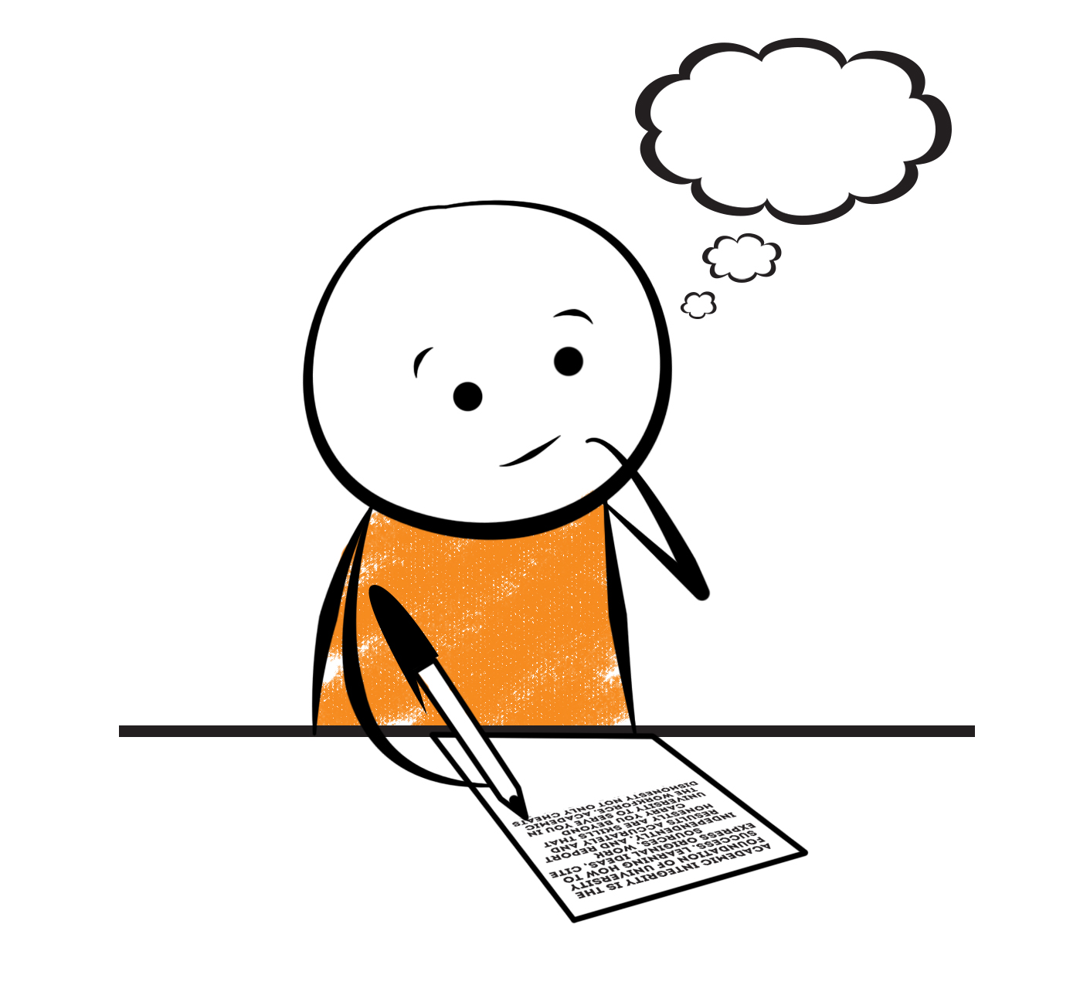

**2nd Grade Fridge Facts**

**Nov. 27th – Dec. 1st**

[](http://www.google.com/imgres?imgurl=http://pad2.whstatic.com/images/thumb/4/4b/MNKY07.JPG/300px-MNKY07.JPG&imgrefurl=http://www.wikihow.com/Draw-a-Cartoon-Monkey-Face&usg=__R59DajZ-oRuc0Bs2tqwaCqkeyrc=&h=215&w=300&sz=13&hl=en&start=47&zoom=1&tbnid=lFt_dXax-slmVM:&tbnh=121&tbnw=160&ei=ULAwTcbrL8H78AbdsYTQCA&prev=/images?q=cute+cartoon+monkey&um=1&hl=en&rlz=1T4GGHP_enUS412US412&biw=1259&bih=564&tbs=isch:1&um=1&itbs=1&iact=hc&vpx=260&vpy=172&dur=765&hovh=172&hovw=240&tx=97&ty=88&oei=RbAwTZWMM8WxtAar4aiHCg&esq=3&page=3&ndsp=22&ved=1t:429,r:16,s:47)

Science

**Forms of Energy**

Social Studies

Creek and Cherokee Indians

**.**

[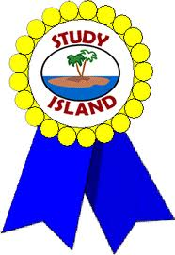](http://www.google.com/imgres?imgurl=http://see.edmonson.k12.ky.us/index_files/StudyislandRibbon.gif&imgrefurl=http://www.millstone.k12.nj.us/teachers/millerj/index.htm&usg=__kVi5j8TDMQias-or_zRD46GlXUQ=&h=366&w=251&sz=11&hl=en&start=7&zoom=1&tbnid=CdoraXaINdFg6M:&tbnh=122&tbnw=84&ei=FamGTdn6B-ay0QHJkfzjCA&prev=/images?q=study+island&um=1&hl=en&rlz=1T4GGHP_enUS412US412&biw=1259&bih=564&tbs=isch:1&um=1&itbs=1)9th

**Important Reminders**

* School starts promptly at 7:45. Please make sure your

child is on time. Drop off begins at 7:10 am.

* If your child has a change in transportation, please

send his/her teacher a note.

*This year, our school is collecting Pop Tarts for the “Paw Packs” Weekend Snack Program. All donations are greatly appreciated!

* December 4 – 8 – Santa Shop

* December 5 & 7 – Christmas Caroling in the Lobby

* December 7 – Camp Christmas Program 6 – 8 pm

* December 12 – Parent’s Night Out 7 – 8 pm

* December 21 – Classroom Christmas Parties

* December 22 – January 5 – Christmas Holidays (Students return to school on Mon., Jan. 8th.)

* January 12 – Report Cards

|  |  |
| --- | --- |
|  |  |
|  | |

**Reading**

We will begin reading “The Kidnapped King” **(L.9)** by Ron Roy. We will concentrate on comprehension, fluency, vocabulary, and increasing our knowledge of conflict and resolution within the plot of a story.

**Tuesday, December 12**

Comprehension Test on “The Kidnapped King” **(L.9)**

**Monday, December 4**

Spelling/Vocabulary Test with **Lesson 9** words

**\*Please continue to practice reading Fry Words.\***

Our lunchtime is at 11:57. You are welcome to

matter.

M

**Group 2 Spelling Words (L.9) “The Kidnapped King”**

felt creep yeast

shelter steep neat

spread beet kneed

dead feast leaven

head beast mislead

**Math**

We will continue to focus our attention on using mental math as a strategy to solve subtraction problems. We will work on fluently adding and subtracting within 100 using mental strategies such as place value, properties of operations, and/or the relationship between addition and subtraction. Students will subtract tens and ones, find parts of 100 (ex. 72+__= 100), subtract on a hundred chart, and subtract multiples of 10. Please continue to practice those basic addition and subtraction facts at home.



**2nd Grade Teacher’s**

**Contact Information**

E-mail:

[kellybryson@.pickenscounty](mailto:kellybryson@.pickenscounty) schools.org

[matthewgibson@.pickenscountyschools.org](mailto:matthewgibson@.pickenscountyschools.org)

[lizpatrick@.pickenscounty schools.org](mailto:lizpatrick@.pickenscounty%20schools.org)

[agaylayoung@.pickenscounty schools.org](mailto:agaylayoung@.pickenscounty%20%20schools.org)

**Phone**:

706-253-1730

School Webpage:

<http://jasperele.pickens.k12.ga.us/>

(You will find links on the school’s webpage to all of the second grade teachers’ webpages.)

**Vocabulary Words (L.9) “The Kidnapped King”**

**culture** – is a noun that means the set of customs or habits of a group of people who live near one another.

**prince** – a noun that means a boy who will become king some day when his father dies. In some countries, like England, there is a king or queen, and their son is called a prince.

**kaleidoscope** – a noun that means a toy tube filled with glass that can move. You look through one end and see colored reflections from the glass.

**react** – a verb that means to act differently.

 ou

**Group 1 Spelling Words (L.9)**

**“The Kidnapped King”**

felt creep yeast

shelter steep neat

spread beet

dead feast

head beast