**2nd Grade Fridge Facts**

**August 28th–Sept. 1st**

In writer’s workshop, young authors will learn to plan, draft, revise, edit and publish their Narrative pieces.

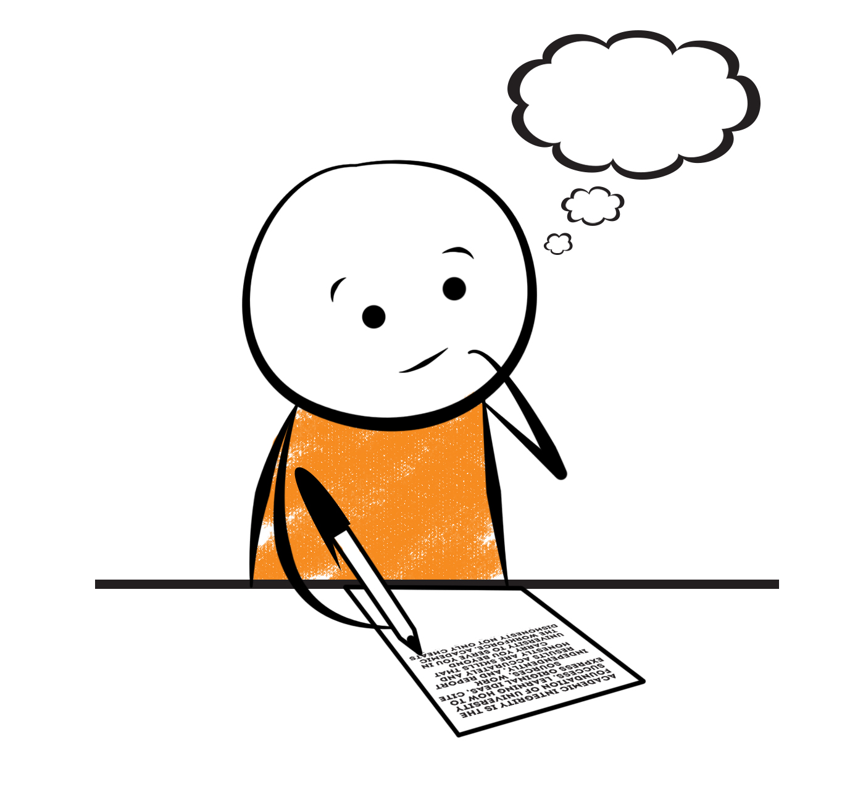

[](http://www.google.com/imgres?imgurl=http://pad2.whstatic.com/images/thumb/4/4b/MNKY07.JPG/300px-MNKY07.JPG&imgrefurl=http://www.wikihow.com/Draw-a-Cartoon-Monkey-Face&usg=__R59DajZ-oRuc0Bs2tqwaCqkeyrc=&h=215&w=300&sz=13&hl=en&start=47&zoom=1&tbnid=lFt_dXax-slmVM:&tbnh=121&tbnw=160&ei=ULAwTcbrL8H78AbdsYTQCA&prev=/images?q=cute+cartoon+monkey&um=1&hl=en&rlz=1T4GGHP_enUS412US412&biw=1259&bih=564&tbs=isch:1&um=1&itbs=1&iact=hc&vpx=260&vpy=172&dur=765&hovh=172&hovw=240&tx=97&ty=88&oei=RbAwTZWMM8WxtAar4aiHCg&esq=3&page=3&ndsp=22&ved=1t:429,r:16,s:47)



[](http://www.google.com/imgres?imgurl=http://see.edmonson.k12.ky.us/index_files/StudyislandRibbon.gif&imgrefurl=http://www.millstone.k12.nj.us/teachers/millerj/index.htm&usg=__kVi5j8TDMQias-or_zRD46GlXUQ=&h=366&w=251&sz=11&hl=en&start=7&zoom=1&tbnid=CdoraXaINdFg6M:&tbnh=122&tbnw=84&ei=FamGTdn6B-ay0QHJkfzjCA&prev=/images?q=study+island&um=1&hl=en&rlz=1T4GGHP_enUS412US412&biw=1259&bih=564&tbs=isch:1&um=1&itbs=1)9th

Social Studies

Regions of GA

Science

**Earth Science - Space**

**Important Reminders**

* Please place money sent in for lunch, afterschool, etc.

in an envelope labeled with your child’s name, grade,

homeroom teacher’s name, amount of money and

its purpose.

*School starts promptly at 7:45. Please make sure your

child is on time. Your child may be dropped off as

early as 7:10.

*If your child has a change in transportation, please

send his/her teacher a note.

*August 29 – Parent/Volunteer Training 9am & 6pm

*August 30 – Butter Braids Fundraiser Due!

*September 4 – Labor Day (No School)

* September 5 – 8 – Book Fair

*September 6 – Lunch with a Loved One at 10:25 am

*September 12 – Curriculum Night 5:00-7:00 pm

|  |  |
| --- | --- |
|  |  |
|  | |

**Reading**

We will continue reading “Pinky and Rex” **(L.3)** by James Howe. We will continue to concentrate on comprehension, fluency and increasing our knowledge of text structure.

**Thursday, August 31**

Comprehension Test on “Pinky and Rex” **(L.3)**

**Wednesday, August 30**

Spelling/Vocabulary Test **(L.3)**

Our lunchtime is at 11:57. You are welcome to

matter.

M

**Group 2 Spelling Words (L.3)**

trash trace harden

stand star surface

stamp park market

face shark jealous

place remark impress

**2nd Grade Teacher’s**

**Contact Information**

E-mail:

kellybryson@.pickenscountyschools.org

matthewgibson@.pickenscountyschools.org

[lizpatrick@.pickenscountyschools.org](mailto:lizpatrick@.pickenscountyschools.org)

[agaylayoung@.pickenscountyschools.org](mailto:agaylayoung@.pickenscountyschools.org)

**Phone**:

706-253-1730

School Webpage:

<http://jasperele.pickens.k12.ga.us/>

(You will find links on the school’s webpage to all of the second grade teachers’ webpages.)

**Math**

Next week, we will continue to focus our attention on place value. Students will need to understand that the three digits of a three-digit number represent

amounts of hundreds, tens, and ones; e.g., 706

equals 7 hundreds, 0 tens, and 6 ones. In addition, students will need to count within 1000 and skip count by 5s, 10s, and 100s. You can help at home by quizzing your child daily with addition & subtraction flash cards because they will need to be able to fluently add and subtract within 20 using mental strategies. By the end of Grade 2, students should know from memory all sums of two one-digit numbers.



**V**

**Vocabulary Words (L.3) “Pinky & Rex”**

**jealous-** an adjective used for the feeling that you have when you are angry or sad because you want what another person has, or you want more attention.

**impress-**a verb for what you do when you really want to influence someone’s thoughts or feelings in a good way.

**irritate-** a verb that means to anger or annoy someone.

**selfish-** an adjective that means thinking only of what you want.

**distracted-** an adjective that means not thinking about what you should be thinking about.

 ou

**Group 1 Spelling Words (L.3)**

trash trace harden

stand star surface

stamp park market

face shark

place remark