In writer’s workshop, students will plan, draft, & organize. We will begin to focus on the Informational genre & writing to inform.

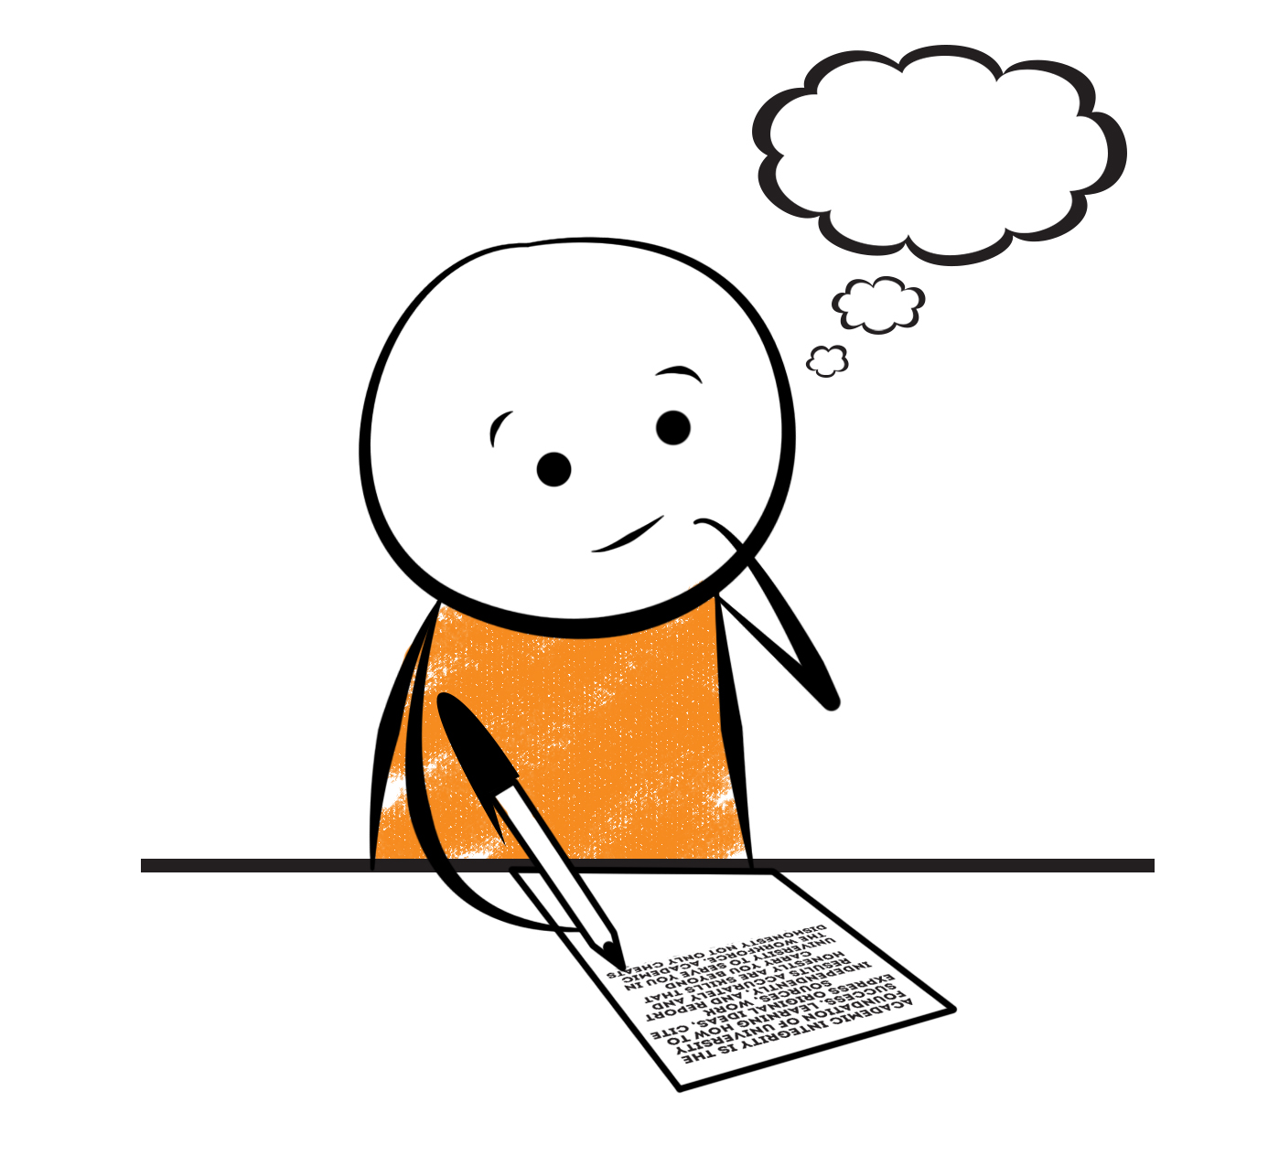

**2nd Grade Fridge Facts**

**Feb. 12th – 16th**

[](http://www.google.com/imgres?imgurl=http://pad2.whstatic.com/images/thumb/4/4b/MNKY07.JPG/300px-MNKY07.JPG&imgrefurl=http://www.wikihow.com/Draw-a-Cartoon-Monkey-Face&usg=__R59DajZ-oRuc0Bs2tqwaCqkeyrc=&h=215&w=300&sz=13&hl=en&start=47&zoom=1&tbnid=lFt_dXax-slmVM:&tbnh=121&tbnw=160&ei=ULAwTcbrL8H78AbdsYTQCA&prev=/images?q=cute+cartoon+monkey&um=1&hl=en&rlz=1T4GGHP_enUS412US412&biw=1259&bih=564&tbs=isch:1&um=1&itbs=1&iact=hc&vpx=260&vpy=172&dur=765&hovh=172&hovw=240&tx=97&ty=88&oei=RbAwTZWMM8WxtAar4aiHCg&esq=3&page=3&ndsp=22&ved=1t:429,r:16,s:47)

Science

Animal & Plant Life Cycles

Social Studies

Creek & Cherokee Indians

**.**

[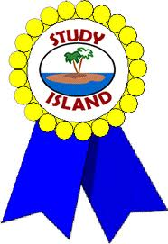](http://www.google.com/imgres?imgurl=http://see.edmonson.k12.ky.us/index_files/StudyislandRibbon.gif&imgrefurl=http://www.millstone.k12.nj.us/teachers/millerj/index.htm&usg=__kVi5j8TDMQias-or_zRD46GlXUQ=&h=366&w=251&sz=11&hl=en&start=7&zoom=1&tbnid=CdoraXaINdFg6M:&tbnh=122&tbnw=84&ei=FamGTdn6B-ay0QHJkfzjCA&prev=/images?q=study+island&um=1&hl=en&rlz=1T4GGHP_enUS412US412&biw=1259&bih=564&tbs=isch:1&um=1&itbs=1)9th

**Important Reminders**

* School starts promptly at 7:45. Please make sure your

child is on time. Drop off begins at 7:10 am.

* If your child has a change in transportation, please

send his/her teacher a note.

*This year, our school is collecting Pop Tarts for the “Paw Packs” Weekend Snack Program. All donations are greatly appreciated!

* February 9 – Progress Reports

* February 12 – 16 – Jump Rope for Heart

* February 14 – “We Love Our Moms” Join us for muffins from 6:45 – 7:45 am.; Valentine’s Day Card Exchange

* February 19 – 20 – Winter Break

* February 21 – 23 – Make-Up Snow Days (School will be in session!)

|  |  |
| --- | --- |
|  |  |
|  | |

**Reading**

We will begin reading “If You Lived with the Cherokee” **(L.14)** by Connie Roop. We will concentrate on comprehension, fluency, vocabulary, and text structure. We will also identify the main ideas and details.

**Wednesday, February 28**

Comprehension Test on “If You Lived with the Cherokee” **(L.14)**

**Friday, February 16**

Spelling/Vocabulary Test with **Lesson 14** words

Our lunchtime is at 11:57. You are welcome to

matter.

M

**Group 2 Spelling Words (L.14) “If You Lived with the Cherokee”**

much tube snuggle

skunk cue excuse

huge clue jungle

prune fruit amuse

flute suit uncle

**Math**

We will continue to focus our attention on subtracting two-digit numbers. This unit of study is similar to the last one except, it is subtracting instead of adding. The main focus in this unit is on regrouping (borrowing). Students will regroup 1ten for 10 ones & practice subtracting two- and one-digit numbers as well as subtracting 2 two-digit numbers. Students will use number lines to model two-digit subtraction. We will also use addition to check subtraction. Please continue to practice those basic addition & subtraction facts at home as well as subtracting with regrouping (borrowing).



**2nd Grade Teacher’s**

**Contact Information**

E-mail:

[kellybryson@.pickenscounty](mailto:kellybryson@.pickenscounty) schools.org

[matthewgibson@.pickenscountyschools.org](mailto:matthewgibson@.pickenscountyschools.org)

[lizpatrick@.pickenscounty schools.org](mailto:lizpatrick@.pickenscounty%20schools.org)

[agaylayoung@.pickenscounty schools.org](mailto:agaylayoung@.pickenscounty%20%20schools.org)

**Phone**:

706-253-1730

School Webpage:

<http://jasperele.pickens.k12.ga.us/>

(You will find links on the school’s webpage to all of the second grade teachers’ webpages.)

**Vocabulary Words (L.14) “If You Lived with the Cherokee”**

**decorate** – is a verb that means to make look nicer.

**ceremony** – is a noun that means a special procedure that we do for a reason. The pledge of allegiance is a short ceremony to show our love of our country.

**council** – is a noun that means a group of people who make decisions.

**leader –** is a noun that means a person who helps others to know what to do.

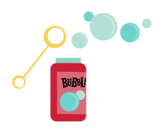 ou

**Group 1 Spelling Words (L.14)**

**“If You Lived with the Cherokee”**

much tube snuggle

skunk cue excuse

huge clue

prune fruit

flute suit