In writer’s workshop, students will plan, draft, & organize. We will begin to focus on the Informational genre & writing to inform.

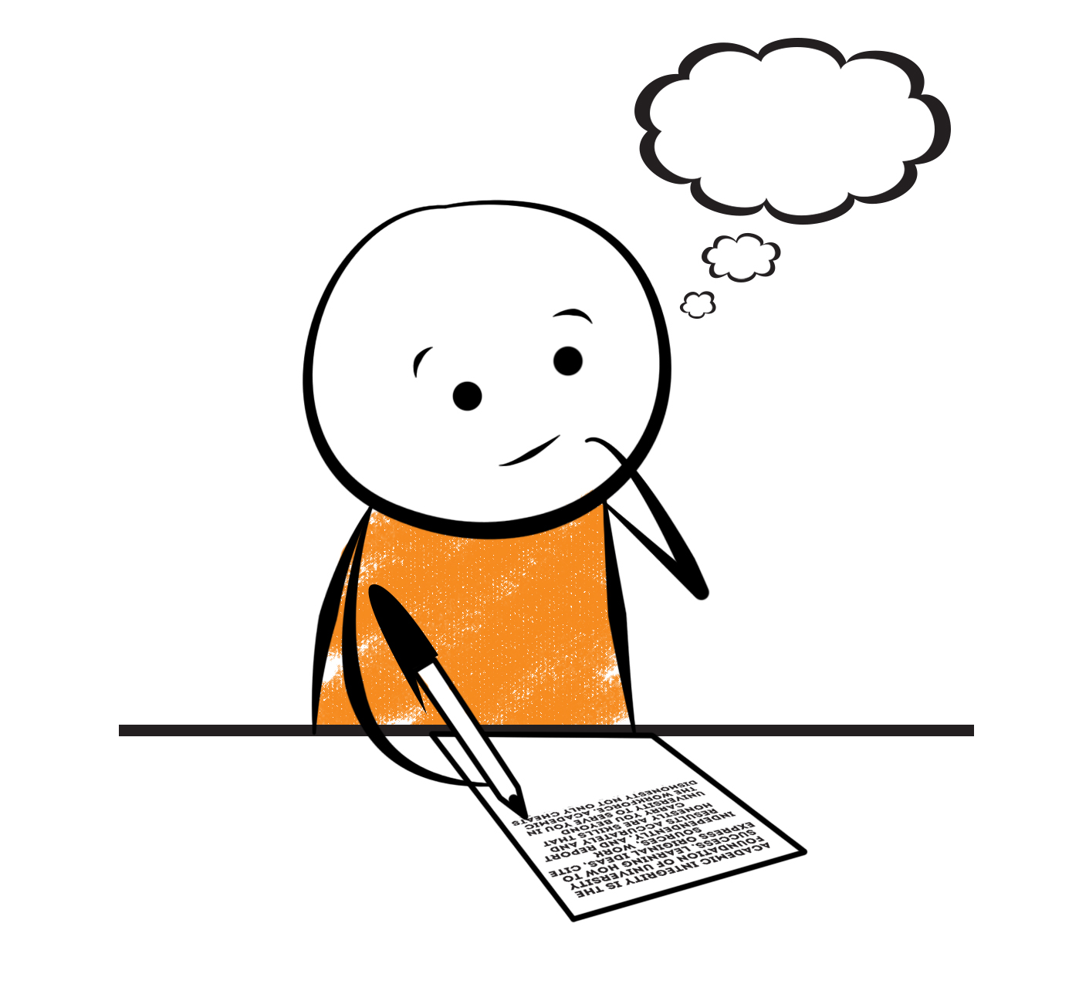

**2nd Grade Fridge Facts**

**Jan. 29th – Feb. 2nd**

[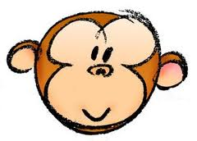](http://www.google.com/imgres?imgurl=http://pad2.whstatic.com/images/thumb/4/4b/MNKY07.JPG/300px-MNKY07.JPG&imgrefurl=http://www.wikihow.com/Draw-a-Cartoon-Monkey-Face&usg=__R59DajZ-oRuc0Bs2tqwaCqkeyrc=&h=215&w=300&sz=13&hl=en&start=47&zoom=1&tbnid=lFt_dXax-slmVM:&tbnh=121&tbnw=160&ei=ULAwTcbrL8H78AbdsYTQCA&prev=/images?q=cute+cartoon+monkey&um=1&hl=en&rlz=1T4GGHP_enUS412US412&biw=1259&bih=564&tbs=isch:1&um=1&itbs=1&iact=hc&vpx=260&vpy=172&dur=765&hovh=172&hovw=240&tx=97&ty=88&oei=RbAwTZWMM8WxtAar4aiHCg&esq=3&page=3&ndsp=22&ved=1t:429,r:16,s:47)

Science

Forms of Energy

Social Studies

Creek & Cherokee Indians

**.**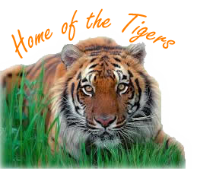

[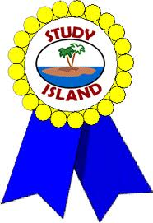](http://www.google.com/imgres?imgurl=http://see.edmonson.k12.ky.us/index_files/StudyislandRibbon.gif&imgrefurl=http://www.millstone.k12.nj.us/teachers/millerj/index.htm&usg=__kVi5j8TDMQias-or_zRD46GlXUQ=&h=366&w=251&sz=11&hl=en&start=7&zoom=1&tbnid=CdoraXaINdFg6M:&tbnh=122&tbnw=84&ei=FamGTdn6B-ay0QHJkfzjCA&prev=/images?q=study+island&um=1&hl=en&rlz=1T4GGHP_enUS412US412&biw=1259&bih=564&tbs=isch:1&um=1&itbs=1)9th

**Important Reminders**

* School starts promptly at 7:45. Please make sure your

child is on time. Drop off begins at 7:10 am.

* If your child has a change in transportation, please

send his/her teacher a note.

*This year, our school is collecting Pop Tarts for the “Paw Packs” Weekend Snack Program. All donations are greatly appreciated!

* February 9 – Progress Reports

* February 12 – 16 – Jump Rope for Heart

* February 14 – “We Love Our Moms” Join us for muffins from 6:45 – 7:45 am.

* February 19 – 20 – Winter Break

* February 21 – 23 – Make-Up Snow Days (School will be in session!)

|  |  |
| --- | --- |
|  |  |
|  | |

**Reading**

We will begin reading “The Very First Americans” **(L.13)** by Cara Ashrose. We will concentrate on comprehension, fluency, vocabulary, and text structure. We will use the semantic feature analysis strategy (chart) to enhance comprehension and vocabulary. **Thursday, February 8**

Comprehension Test on “The Very First Americans” **(L.13)**

**Wednesday, February 7**

Spelling/Vocabulary Test with **Lesson 13** words

Our lunchtime is at 11:57. You are welcome to

matter.

M

**Group 2 Spelling Words (L.13) “The Very First Americans”**

stomp rose blow

drop loan shown

flop moan owner

choke boast crowbar

phone flow boathouse

**Math**

We will begin to focus our attention on subtracting two-digit numbers. This unit of study is similar to the last one except, it is subtracting instead of adding. The main focus in this unit is on regrouping (borrowing). Students will regroup 1ten for 10 ones and practice subtracting two- and one-digit numbers as well as subtracting 2 two-digit numbers. Students will use number lines to model two-digit subtraction. We will also use addition to check subtraction. Please continue to practice those basic addition and subtraction facts at home as well as subtracting with regrouping (borrowing).



**2nd Grade Teacher’s**

**Contact Information**

E-mail:

[kellybryson@.pickenscounty](mailto:kellybryson@.pickenscounty) schools.org

[matthewgibson@.pickenscountyschools.org](mailto:matthewgibson@.pickenscountyschools.org)

[lizpatrick@.pickenscounty schools.org](mailto:lizpatrick@.pickenscounty%20schools.org)

[agaylayoung@.pickenscounty schools.org](mailto:agaylayoung@.pickenscounty%20%20schools.org)

**Phone**:

706-253-1730

School Webpage:

<http://jasperele.pickens.k12.ga.us/>

(You will find links on the school’s webpage to all of the second grade teachers’ webpages.)

**Vocabulary Words (L.13) “The Very First Americans”**

**native** – is an adjective that means “from a place.” We are natives of the state and country we are born in.

**mesa** – is a noun that means a flat-topped mountain. Native Americans in the Southwest chose mesas to build their homes.

**buffalo** – is a noun that means a large animal that was common in the American plains. Buffalo are dark brown, eat grass, and are a good source of meat for people.

**disguise –** is a noun that means to change the way you look so people won’t know who you are.

 ou

**Group 1 Spelling Words (L.13)**

**“The Very First Americans”**

stomp rose blow

drop loan shown

flop moan

choke boast

phone flow