**2nd Grade Fridge Facts**

**October 9th – 13th**

In writer’s workshop, young authors will learn to plan, draft, revise, edit and publish their Narrative pieces.

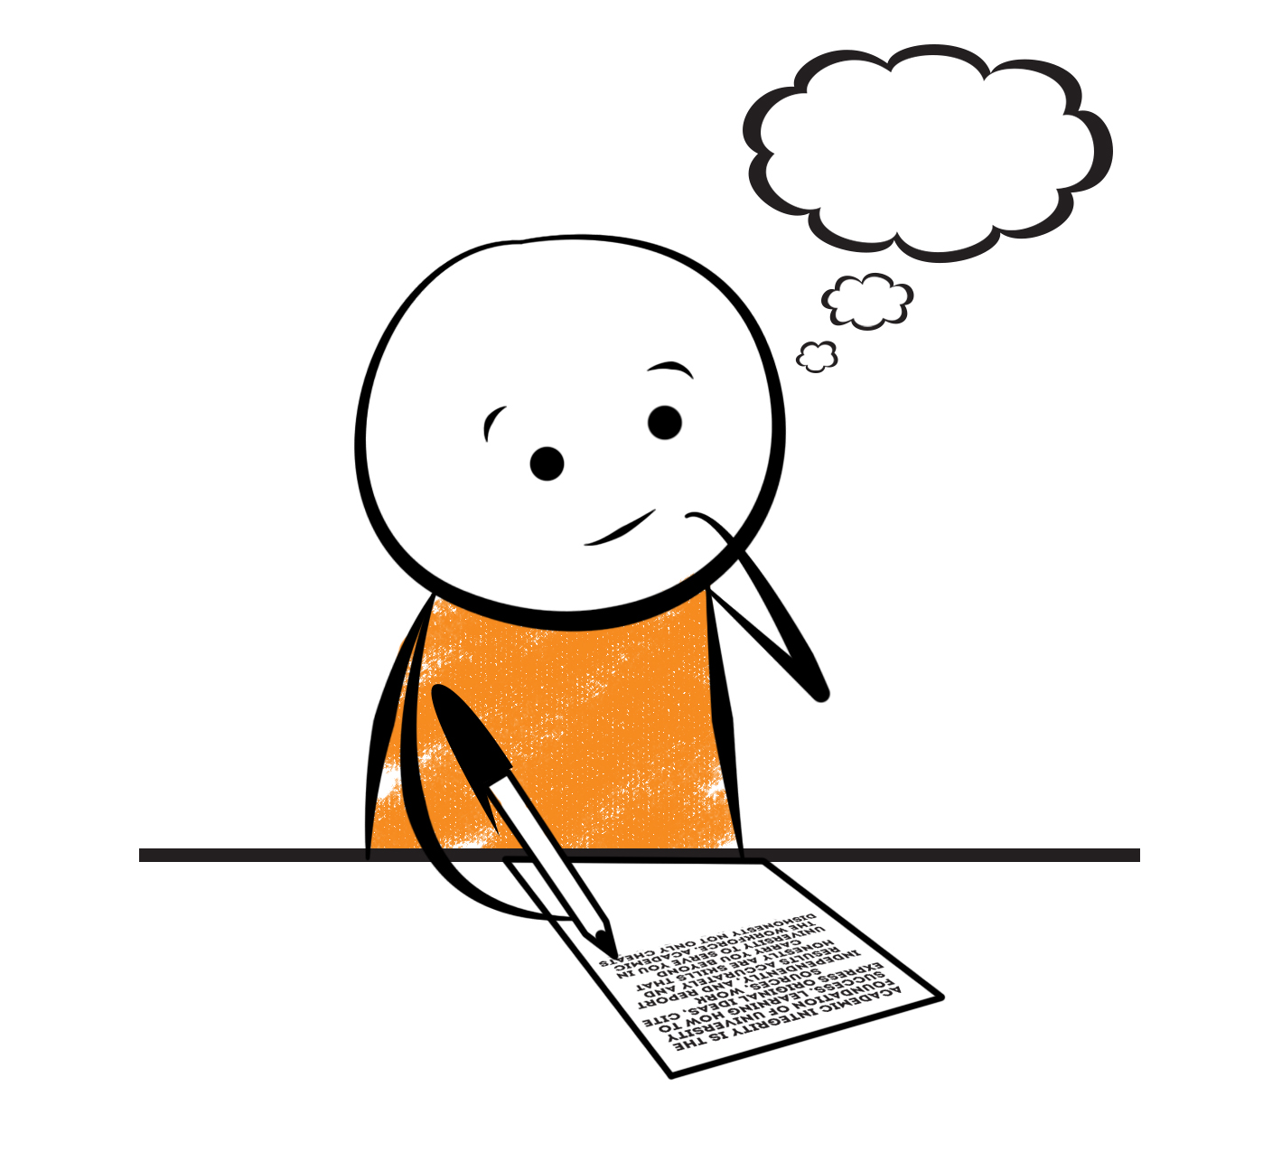

[](http://www.google.com/imgres?imgurl=http://pad2.whstatic.com/images/thumb/4/4b/MNKY07.JPG/300px-MNKY07.JPG&imgrefurl=http://www.wikihow.com/Draw-a-Cartoon-Monkey-Face&usg=__R59DajZ-oRuc0Bs2tqwaCqkeyrc=&h=215&w=300&sz=13&hl=en&start=47&zoom=1&tbnid=lFt_dXax-slmVM:&tbnh=121&tbnw=160&ei=ULAwTcbrL8H78AbdsYTQCA&prev=/images?q=cute+cartoon+monkey&um=1&hl=en&rlz=1T4GGHP_enUS412US412&biw=1259&bih=564&tbs=isch:1&um=1&itbs=1&iact=hc&vpx=260&vpy=172&dur=765&hovh=172&hovw=240&tx=97&ty=88&oei=RbAwTZWMM8WxtAar4aiHCg&esq=3&page=3&ndsp=22&ved=1t:429,r:16,s:47)

Science

**States of Matter**

Social Studies

Being an American Citizen



[](http://www.google.com/imgres?imgurl=http://see.edmonson.k12.ky.us/index_files/StudyislandRibbon.gif&imgrefurl=http://www.millstone.k12.nj.us/teachers/millerj/index.htm&usg=__kVi5j8TDMQias-or_zRD46GlXUQ=&h=366&w=251&sz=11&hl=en&start=7&zoom=1&tbnid=CdoraXaINdFg6M:&tbnh=122&tbnw=84&ei=FamGTdn6B-ay0QHJkfzjCA&prev=/images?q=study+island&um=1&hl=en&rlz=1T4GGHP_enUS412US412&biw=1259&bih=564&tbs=isch:1&um=1&itbs=1)9th

**Important Reminders**

* School starts promptly at 7:45. Please make sure your

child is on time. Your child may be dropped off as

early as 7:10.

*If your child has a change in transportation, please

send his/her teacher a note.

*This year, our school is collecting Pop Tarts for the “Paw Packs” Weekend Snack Program. All donations are greatly appreciated!

* Please send in donations for our Fall Festival Basket – “Outdoors Basket.” Items may include bucket, fishing rod, tackle box, etc.

* October 7 – Marble Festival Road Race (Register by 9/28)

* October 13 – Report Cards will be sent home

* October 20 – Fall Festival 6:00 – 8:00 pm

* October 30 – November 3 – Red Ribbon Week

*

|  |  |
| --- | --- |
|  |  |
|  | |

**Reading**

Next week, we will begin reading “From Tadpole to Frog” **(L.6)** by Wendy Pfeffer. We will concentrate on comprehension, fluency, vocabulary, & increasing our knowledge of text structure (sequential organization).

**Monday, October 9**

Comprehension Test on “Tale of a Tadpole” **(L.5)**

**Tuesday, October 17**

Spelling/Vocabulary Test **(L.6)**

Our lunchtime is at 11:57. You are welcome to

matter.

M

**Group 2 Spelling Words (L.6) “From Tadpole to Frog”**

snag strange replay

span clay payment

scrape play graceful

shape may shaping

paste gray

**2nd Grade Teacher’s**

**Contact Information**

E-mail:

[kellybryson@.pickenscounty](mailto:kellybryson@.pickenscounty) schools.org

[matthewgibson@.pickenscountyschools.org](mailto:matthewgibson@.pickenscountyschools.org)

[lizpatrick@.pickenscounty schools.org](mailto:lizpatrick@.pickenscounty%20schools.org)

[agaylayoung@.pickenscounty schools.org](mailto:agaylayoung@.pickenscounty%20%20schools.org)

**Phone**:

706-253-1730

School Webpage:

<http://jasperele.pickens.k12.ga.us/>

(You will find links on the school’s webpage to all of the second grade teachers’ webpages.)

**Math**

Although we will start a new unit next week, our main focus will still be on understanding addition & subtraction. Students will continue to use addition strategies such as doubles facts, or making ten as well as subtraction strategies such as “thinking addition” to subtract. Students will continue to write number sentences & solve story problems using a variety of addition & subtraction strategies. Please continue to help at home by quizzing your child with addition & subtraction flash cards because they will need to be able to fluently add and subtract within 20 using mental strategies.



**Vocabulary Words (L.6) “From Tadpole to Frog”**

**hibernate-** to sleep for a long time.

**hatch-** to break out of an egg.

**trait-** Animals have traits, or characteristics that help them survive. Animal traits are not personalities. They are features and talents. One trait of frogs is that they live mostly in water.

**sequence-** “From Tadpole to Frog” is a sequence. Events are told in time order.

 ou

**Group 1 Spelling Words (L.6) “From Tadpole to Frog”**

snag strange

span clay

scrape play

shape may

paste gray